

**Expanding into New Markets**

**CS782 – IT Strategy and Management**

**Assignment No. 5**

Sneha Puttamaraiah

Boston University

psneha@bu.edu

*Abstract*:

Globalization has turned out to be a major strategy for corporations to expand their processes worldwide to attain competitive benefits. The *Chaulkboard* Corporation has hit a juncture for evolution and pursues to gain additional profits by expanding nationally and globally. The corporation is considering moving its data center to the cloud. This paper will answer:

How will the current system transition to the new system?

How will globalization and resource balancing align with the plan?

What are the costs and risks of not having a disaster recovery plan?

How is a disaster recovery plan different from a business continuity plan?

Table of Contents

INTRODUCTION 1

SYSTEM ROLL OUT AND TRANSITION 2

INITIATION PLANNING 3

• Project Initiation 3

• Preliminary Analysis 4

• Functional Requirements 5

SYSTEM PLANNING 6

• System Design and Evaluation 6

• Feasibility Impact and Analysis 7

• Commitment 7

IMPLEMENTATION PLANNING 7

GLOBALIZATION AND RESOURCE BALANCE 8

DISASTER RECOVERY PLAN 11

BUSINESS CONTINUITY 14

CONCLUSION 16

REFERENCES 16

Table of Figures

Figure 5 - 1 SaaS Vs. On-Premises Software 1

Figure 5 - 2 Five Phases of Project Planning 3

Figure 5 - 3 Critical Non-Functional Requirements for A Saas Application 6

Figure 5 - 4 Return On Investment (ROI) Analysis of Saas Platform 7

Figure 5 - 5 SaaS Implementation Roadmap 8

Figure 5 - 6 Cloud Spending Rate and Growth Per Country 9

Figure 5 - 7 Offshoring Vs. Outsourcing 10

Figure 5 - 8 Cloud Disaster Recovery Plan 11

Figure 5 - 9 Amazon’s Disaster Recovery For AWS 12

Figure 5 - 10 Total Cost of Outage 13

Figure 5 - 11 Risks of Not Implementing Disaster Recovery Plan 14

Figure 5 - 12 Disaster Recovery Vs. Business Continuity 15

INTRODUCTION

The *ChaulkBoard Corporation* provides software (e-learning platforms) that allow institutions to distribute educational content to their students. Companies, community colleges, and universities are the clients of the *ChaulkBoard Corporation*. Covid-19 increased the demand for online educational platforms. The corporation has its base in New York and is looking to expand into other cities and countries.

Currently, the corporation provides on-premises software to its clients, where the clients install and run in their company’s computing infrastructure and in-house server. Clients can purchase a copy of software online or get it shipped from the *ChaulkBoard Corporation*, where the copy of software is delivered in a CD or DVD. However, in this type or model, not only the product manufacturing and shipping costs are high, even the support and deployment costs are high. Due to high costs, the corporation is being pressured by clients to reduce costs. To make it cost-effective, the executive team at the *ChaulkBoard Corporation* has decided to move the educational software platform to the Software as a Service (SaaS) model.

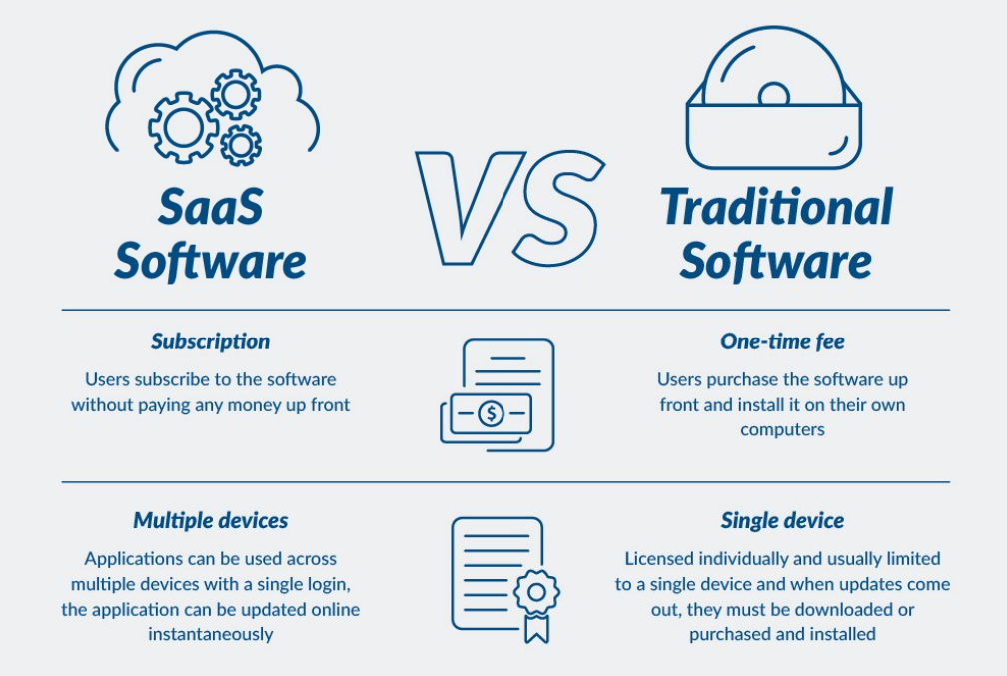

Figure 5 - 1 SaaS Vs. On-Premises Software

*Source: https://www.atlantic.net/wp-content/themes/anet/img/what-is/saas/what-is-saas-15.jpg*

Figure 5 - 1 points out the differences between on-premises software and SaaS software.

Apart from reduced costs, there are other benefits to shift to SaaS such as decreased support and quick deployment. Even though SaaS can be one of the wisest business solutions and offers great benefits, it is important to build SaaS that is efficient and offers demonstrated results to clients. It is important to note how the corporation plans around rolling out and transitioning to new systems, how resource balancing and globalization align with the plan, how the corporation recovers from disasters, and finally, how the corporation offers business continuity.

SYSTEM ROLL OUT AND TRANSITION

To roll out the system, the *ChaulkBoard* Corporation shall arrange for an early implementation throughout the organization and take required measures as soon as the SaaS platform is in place. The modifications arising due to transition should be communicated to personnel and end-users who will be affected by the transition. (Herrick) The associated project manager shall develop a planning and training program that can provide a model for all personnel and end-users before the project is implemented.

All users of the system will be emphasized on the significance of the transition, so they realize the vitality of the transition. They will be insisted to sort out the new system as there are no other alternatives. A dedicated staff member will be assigned to observe the integration process and the following weeks once the SaaS-based platform is launched. Training programs and documents will be put in place to help current and prospective employees to help understand and use the new system. The UI/UX team will be provided with classroom training to enhance or develop the skills and knowledge needed to make the new system work. With SaaS, there is not much need for on-site support and maintenance technicians, so the support team will be downsized. The remaining support employees will have to be moved around to different teams where they are encouraged to develop skills relevant to the new system. Since the company’s base is primarily in the US, the technical documentation is written in English by default. The company will be expanding its operations to Canada, Australia, Brazil, and India, so the documentation needs to be translated into these countries’ languages.

The corporation will require cloud migration experts that are experienced in cloud technologies to make this transition successful. The corporation shall move every part of its data center resources to the cloud. The on-premises database shall be isolated once all the data has been migrated to the cloud. However, it is critical to realize the intricacy of cloud migration because preparing poorly can lead to futile migration attempts. It may take several months or years to migrate completely and abandon the existing data center. Netflix benefited greatly from moving its data to Amazon Web Services (AWS) cloud and spent 7 years migrating the data before successfully shutting down their data center. (Netflix, 2016)

The pressure to implement the project can quickly compress the planning phase and increase the likelihood that important aspects of the project will be overlooked. Poor execution and inadequate planning can lead to unsuccessful projects. Inadequate planning triggers many project execution problems. (Module 5) The following figure reveals the phases of project management.

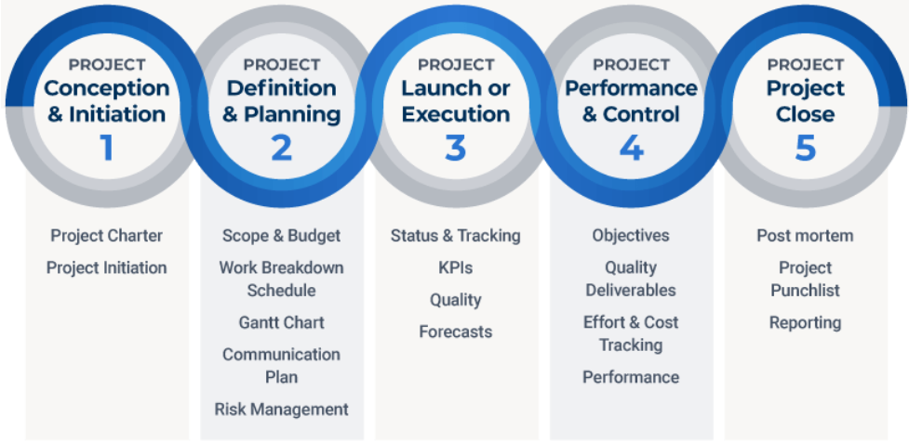

Figure 5 - 2 Five Phases of Project Planning

*Source: Smartsheet*

There are 3 phases of planning: initiation planning, system planning, and implementation planning. These 3 phases are discussed in the following sections.

INITIATION PLANNING

Initiation planning is the starting phase of project planning, and it involves identifying the objectives, scope, stakeholders, functionality, and governance of the project. (Module 5) Initial planning consists of 3 phases:

* **Project Initiation**

This phase provides an evident knowledge on the project. This phase starts by providing reasoning for embarking on the project. The reasoning answers why the project is needed and how it adds value. The stakeholders of the project need to be involved to ensure the project meets their needs. The primary stakeholders of the project are end-users, cloud developers, test engineers, admins, and top-level management. Following this, the decision whether to carry out the project or not is made.

Reasoning: The need for SaaS-based educational platforms stems from the clients complaining about cost and complicated installation and deployment. SaaS offers rapid deployment which eliminates the need for an experienced IT personnel’s support. This helps the corporation save time and increase profits. Implementation of a SaaS-based platform will enable users to use software remotely which is especially beneficial during the pandemic.

Since students and management will have surplus command over their knowhow, an entire IT team is not required to sustain and experience a SaaS-based educational platform. End-users need not worry about maintenance or repairs as several tools for integrations pave the way for top-notch user experience and training programs. SaaS-based e-learning platform provides high scalability so the organization can accommodate growing number of users.

* Preliminary Analysis

This phase intends to reveal any challenging barriers that would bestow a futile feasibility testing of the SaaS platform. This phase validates the project goals and identifies risks determining project costs, schedule, complexity, etc.

The following POWS (problems, opportunities, weaknesses, strengths) chart provides a preliminary analysis reviewing the problems, opportunities, weaknesses, and strengths corresponding to organizational and competitive questions.

|  |  |  |
| --- | --- | --- |
|  | **Competitive** | **Organizational** |
| **Problems** | How will this IT project help counter threats from  competitive and environmental forces?   * Helps come up with a patented offering to convince clients * Reduces on-premises infrastructure * Reduces ownership costs | How will this IT project help overcome ineffective organizational  characteristics and capabilities?   * Supports frequent communication with developers to ensure they are on the same page regarding requirements and features of the new system * Constant upkeep and updates keep employees functioning |
| **Opportunities** | How will this IT project help a company expand or  extend its business model?   * Offers high availability and scalability * Offers free trials to current and possible consumers * Helps focus on storytelling | How will this IT project help the organization excel in its  characteristics and capabilities?   * Makes teams extra productive * Allows numerous individuals to operate under the same software group |
| **Weaknesses** | Which competitive and environmental factors will hinder  the success of the project?   * Inability to work offline as the project requires enduring connection to the Internet * External agents like public administration in other countries may have concerns regarding data security | Which organizational or operational characteristics and capabilities will hinder the success of the project?   * Not onboarding people early on * Obsolete training programs * Poor adoption and implementation strategies can affect employees’ alignment with the project |
| **Strengths** | Which competitive and environmental factors will  support the success of the project?   * Actively advertising the project * Government policy and regulations in favor | Which organizational or operational characteristics and capabilities will support the success of the project?   * Potential to subjugate scarcity of expertise and familiarity in adoption * Top-level management fathoms IT and fosters adoption |

* Functional Requirements

This phase describes the capabilities that the intended product can perform to enable business users to do some part of their work and carry on with their business (operational) work. (Kumar, V.S., 2006)

The tool should allow new authorized users to register, and their sign-in credentials must be verified. The tool will be able to retrieve progress reports and other student data. Students should be able to upload assignments and instructors should be able to upload class materials. The following image outlines non-functional requirements for a SaaS application.

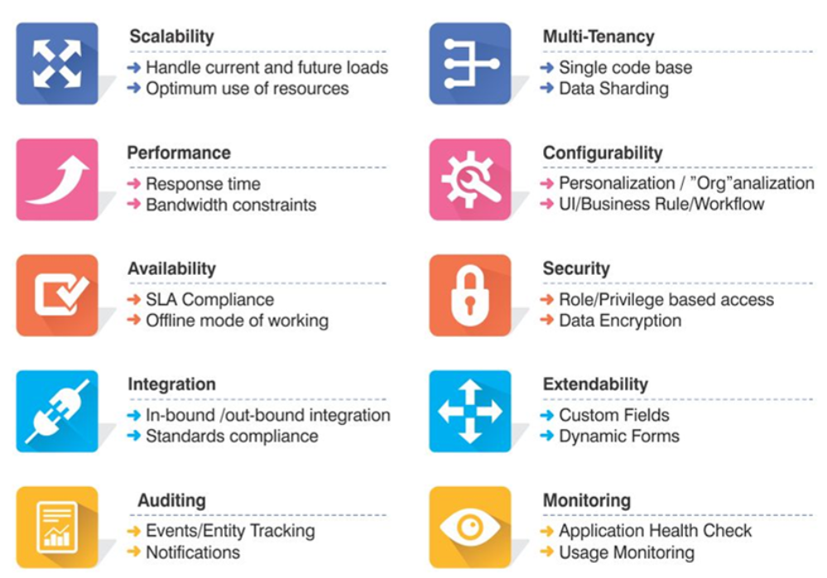

Figure 5 - 3 Critical Non-Functional Requirements for A Saas Application

*Source: https://blog.techcello.com/top-10-critical-nfr-for-saas-applications-part-1/*

SYSTEM PLANNING

This phase decides which architecture, components, and technologies are required to implement the project. System planning is divided into the following three categories.

* System Design and Evaluation

Technological problems concerning data, servers, storage, and middleware will be handled by the IT team at the *ChaulkBoard* Corporation. Since the company has plans to expand, some of the key features to include in the SaaS-based educational platform would be (DevCom, 2020):

* Application and data security
* High availability
* Multi-tenant architecture, where a single copy of software provides service to many customers.
* Single sign-on to allow users to authenticate themselves across various related applications with the same set of credentials.
* Automate provisioning to generate new accounts in the right systems for new users when they join an organization. (Microsoft, 2021)

The application shall be built using:

* Front end technologies such as HTML, CSS, and JavaScript
* Server-side technologies such as PHP, JavaScript, or Python
* Frameworks such as Angular and React
* Back-end data storage will use a relational database such as MySQL or PostgreSQL
* Feasibility Impact and Analysis

Implementing a SaaS solution into the existing e-learning platform will retain existing customers as well as gain new customers. The SaaS model will decrease costs associated with operations and maintenance. Clients will be charged on a subscription basis. According to PR Newswire, “the global software as a service (SaaS) market was valued at about $134.44 billion in 2018 and is expected to grow to $220.21 billion at a CAGR of 13.1% through 2022.”

The succeeding figure depicts the ROI valuation with cumulative costs, net value, and ROI over 5 years. (Oliver, 2018)

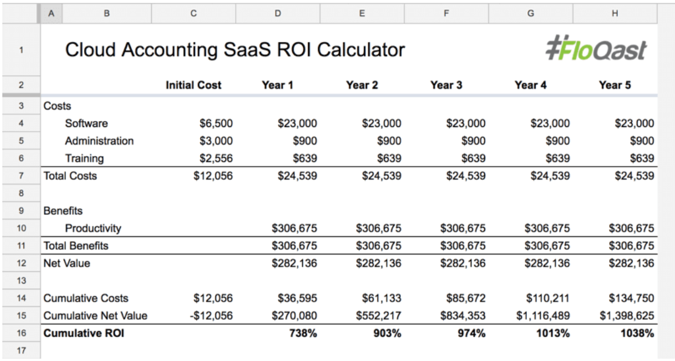

Figure 5 - 4 Return On Investment (ROI) Analysis of Saas Platform

*Source: https://floqast.com/blog/accounting-software-roi-analysis-calculator/*

* Commitment

The corporation will focus on building a minimum viable product (MVP) of the SaaS-based educational platform. The MVP will have the most basic features that will be implemented in the platform. This will act as a prototype for the stakeholders and users to see how the product is accepted in the market before developing the actual product. This will allow for any changes in the technology stack identified in the system evaluation and design phase.

IMPLEMENTATION PLANNING

This phase begins by evaluating the current environment and decides if the functionality of the on-premises infrastructure is worth advancing. The deployment will consider a pilot approach to transition to the new system. Note current expenses and resourcefulness of existing infrastructure. Identify the applications that need to be moved to the new system including storage, service level agreements (SLA), and analytics. Calculate expenses of maintaining data centers and any hidden expenses to optimize applications.

The following figure provides a general roadmap to implementation of SaaS.

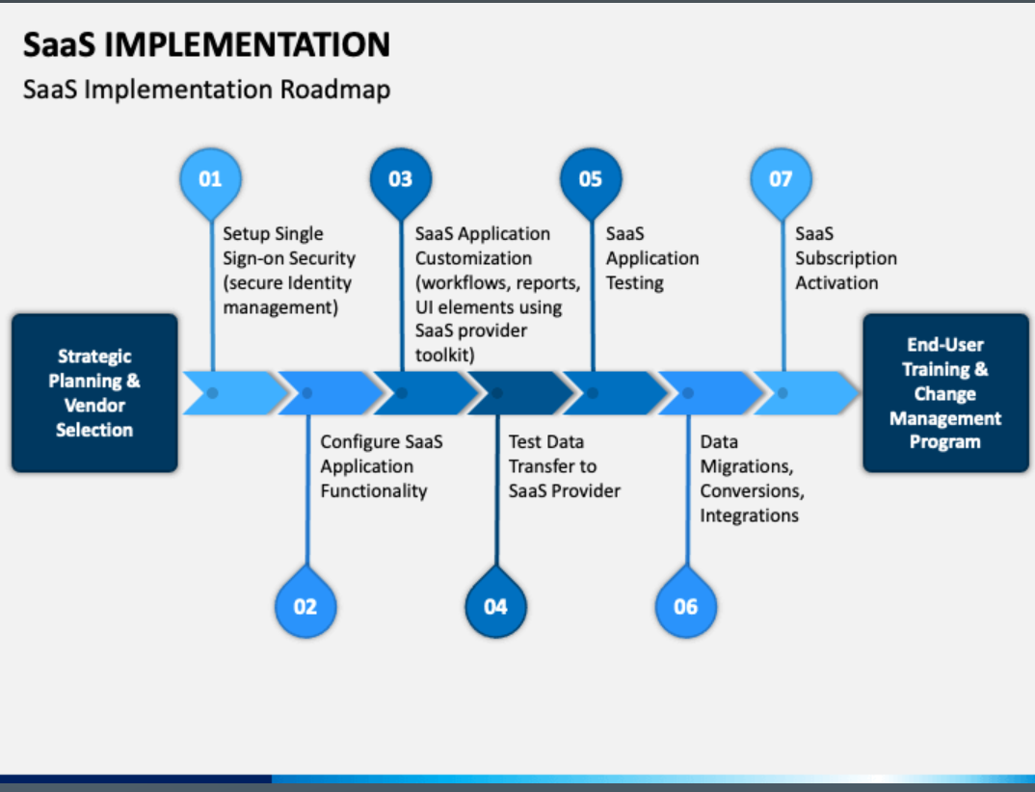

Figure 5 - 5 SaaS Implementation Roadmap

*Source: https://www.sketchbubble.com/en/presentation-saas-implementation.html*

Before setting up the cloud environment, backup the current data of customers and servers and make sure the applications will work in the cloud environment. Then, continually migrate data to the cloud environment. Shift to production to find out how the product works on the cloud. Before releasing the product, it shall be tested in-house to ensure there are no defects. It is possible that end-users detect defects, so the corporation shall fix them according to their feedback and provide upgrades.

GLOBALIZATION AND RESOURCE BALANCE

The ChaulkBoard Corporation will expand globally and will operate in Canada, Australia, Brazil, and India, so the documentation needs to be translated into these countries’ languages. Although the majority of the population in Canada and Australia speak English, there are populations that speak other languages. For example, Quebec and Nunavut are French-speaking provinces. According to SBS News, the second-most spoken language in Australia is Mandarin followed by Arabic, Cantonese, and Vietnamese. The corporation can benefit when businesses stem from non-English provinces if they have documentation written in their corresponding language. From the following image, it can be observed that countries like the UK, Canada, Australia, Brazil, Netherlands, and Poland are leading and have better adoption rates. The countries that are slow to adopt cloud are categorized as Lagging Countries and the countries that are refusing to adopt cloud are categorized as Resisting Countries. (Goasduff, 2019)

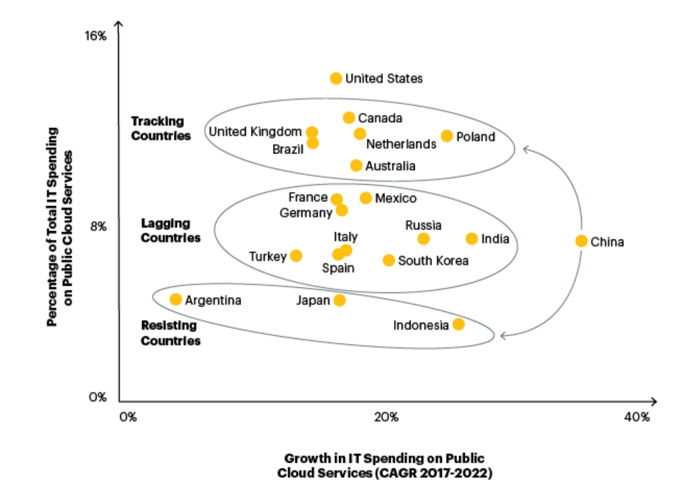

Figure 5 - 6 Cloud Spending Rate and Growth Per Country

*Source: https://www.gartner.com/smarterwithgartner/cloud-adoption-where-does-your-country-rank*

According to Stephen Carpenter writing for TechCrunch in 2015:

“When 25 percent or more of your business is coming from international markets, it’s time to scale outside your home country.”

The project managers at the *ChaulkBoard Corporation* will be responsible for balancing resources by evaluating current plans as well as schedules and indicating any adjustments that may promote coordinated production and improved phasing. It will involve reallocating resources and rescheduling tasks.

The new SaaS application will be part of the ChaulkBoard Corporation as it can add value to the business and enhance brand recognition furthermore. Some aspects of development and testing will be offshored to India or Brazil as they have cheaper economies. The customer support team will be majorly from India as it serves as one of the cheapest offshoring options. The corporation shall outsource when a specific capability outside the corporation is needed. The corporation shall outsource equipment maintenance. Despite the benefits, there are some risks associated with both offshoring and outsourcing. The following table outlines the risks and benefits of offshoring and outsourcing.

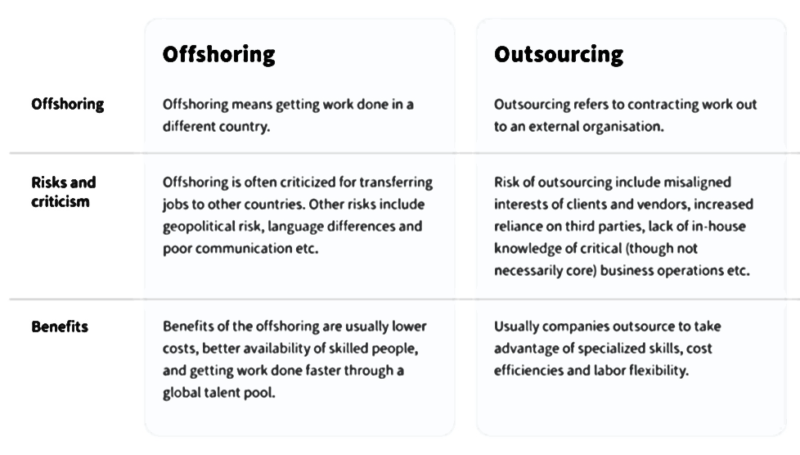

Figure 5 - 7 Offshoring Vs. Outsourcing

*Source: https://nix-united.com/blog/the-differences-between-outsourcing-and-offshoring/*

Outsourcing risks can be resolved by keeping the vendor’s IT management team in alignment with the *ChaulkBoard* Corporation’s changing strategic objectives. Although, doing so extensively can be very overwhelming. However, outsourcing can still add value to the company as it can help with better strategic decisions and restructure the corporation to set it up for success.

Offshoring risks can be resolved by improving communication by considering the time zone difference. The work force’s timing in the US shall overlap with work timings in India. The development team in New York shall work 8 am to 5 pm EST and the Indian development team shall work 2 pm to 10 pm IST. Cultural differences such as public holidays may impact the schedule, so the public holidays will be cut to a minimum and on rotation basis. For example, Indian festival like Diwali makes way for 4 public holidays which can be cut off to 2 days. Another option is providing holidays on a rotation basis, so someone who took an off on Diwali will not get an off on Christmas Day but will allow someone else to apply for leave. To further counter issues associated with offshoring, the company will expand nationwide in states like Minnesota, Nevada, and Nebraska. According to Forbes, software developers in these states earn the least.

DISASTER RECOVERY PLAN

Uptime and recuperating from outages are essential to the ChaulkBoard Corporation’s triumph. Clients look forward to the maximum possible availability, and guidelines and procedures as a corporation are positioned around ensuring the maximum possible uptime and availability for customer data. (Salesforce, 2021)

The following image outlines a disaster recovery plan for a cloud-based service.

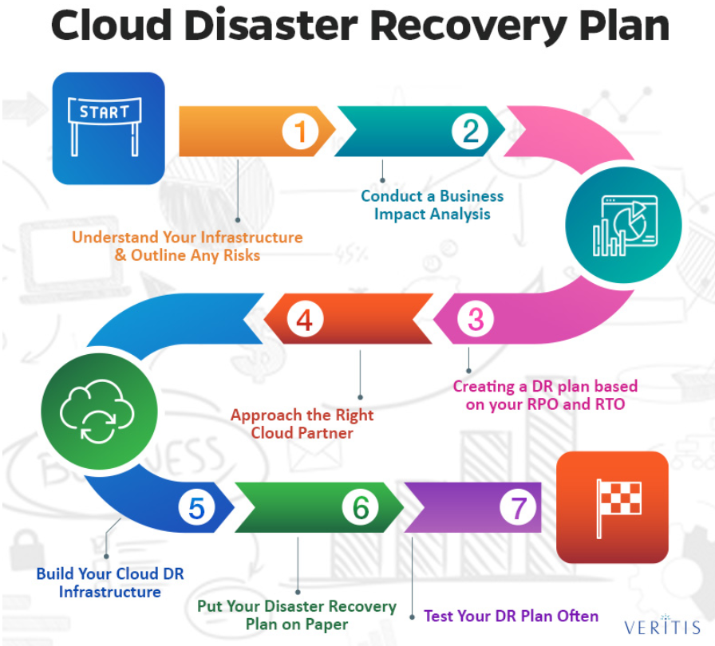

Figure 5 - 8 Cloud Disaster Recovery Plan

Source: https://www.veritis.com/blog/how-to-plan-an-effective-cloud-disaster-recovery-strategy/

The following data recovery plans shall be adopted by the ChaulkBoard Corporation to handle disasters and outages:

* Each front-end on the system shall have several copies, so one front-end shall not cause the site to be unreachable. (Salesforce, 2021)
* Every database is shared with several instances, so when there is a problem pertaining to one customer, it shall not make the site unreachable to other customers. (Salesforce, 2021)
* The corporation’s critical IT systems shall be housed in a secondary region far from New York. Minnesota will be this secondary region as it has the least risk from climate change according to an article by *The New York Times*.
* Ensure employee safety by organizing emergency rescue operations ahead of time.
* An effective communication plan will be put in place when a disaster occurs to let everyone know which departments are affected by the disasters. Determine how employees are affected when their systems and/or networks are unavailable.
* Monitor security holes by updating software as soon as upgrades become available and ensure there is no erroneous or malicious code.
* Create a mutual benefit with other cloud partners such as Amazon or Microsoft to obtain alternate facilities.
* Along with a good disaster recovery plan, it is beneficial to have an insurance as it can help cut down recovery costs.
* The disaster recovery plan shall be tested even before a disaster occurs to make sure it will work in an event where there’ll be a disaster.

Amazon follows the disaster recovery strategies shown in the figure below.

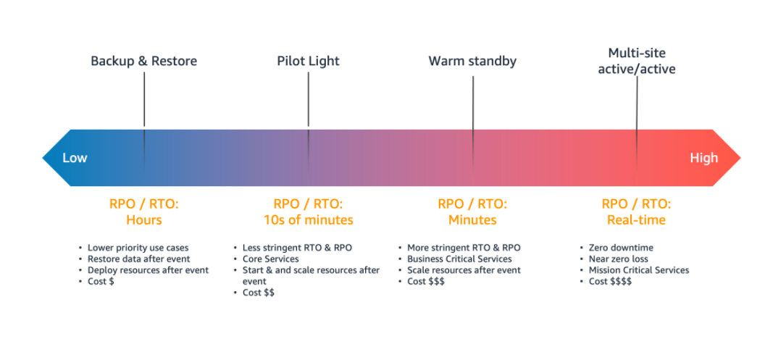

Figure 5 - 9 Amazon’s Disaster Recovery For AWS

*Source: https://docs.aws.amazon.com/whitepapers/latest/disaster-recovery-workloads-on-aws/disaster-recovery-options-in-the-cloud.html*

The cost of a DRP hangs on many factors depending on the type of disaster and how much data was backed up. The downtime cost calculator from Eaton provides the following cost estimates in the event of an outage as shown in the following figure. The ChaulkBoard Corporation loses $4,155,964 per hour and $9000 per minute during an outage. The DRP would cost less than the amount lost due to disruptions caused by disasters.

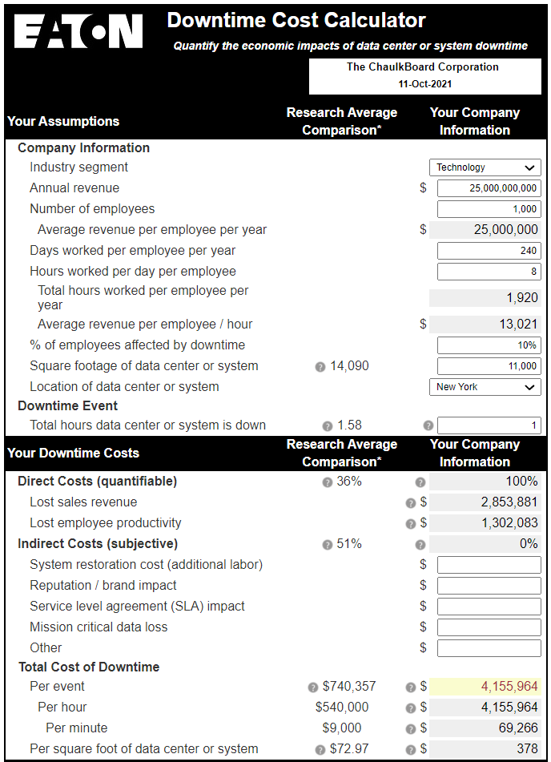

Figure 5 - 10 Total Cost of Outage

*Source: https://powerquality.eaton.com/Products-services/Help-Me-Choose/DowntimeCostCalculator/Default.asp*

The following figure provides information on risks associated with not having a disaster recovery plan (DRP).

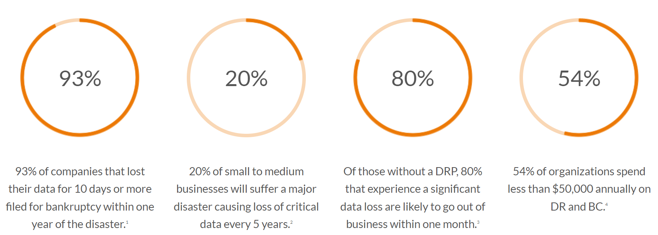

Figure 5 - 11 Risks of Not Implementing Disaster Recovery Plan

*Source: https://www.evolveip.net/*

The following lists some of the risks to the business:

* Data loss – prevented by replicating data and having multiple instances
* Data breach – prevented by imposing strong password policies, configuring cloud, encrypting data, and using multi-factor authentication
* Hackers and malware – prevented by performing code reviews and eliminating security holes
* Insider attacks – supervise user conduct and create warnings when unusual patterns are discovered
* Compliance and legal risks – monitor latest and shifting regulations; legal time should be prepared to prevent and handle fraud
* Natural disaster – move critical systems to disaster-proof location and choose a secondary location that is far away from the primary location

BUSINESS CONTINUITY

A business continuity plan (BCP) is a superset of a disaster recovery plan and is broader as it plans how the business will run in case of an unforeseen interference in service. The disaster recovery plan centers on reestablishing IT systems and operations following a disaster and the business continuity plan centers on reinstating the whole business. The following figure marks the distinction between disaster recovery and business continuity.

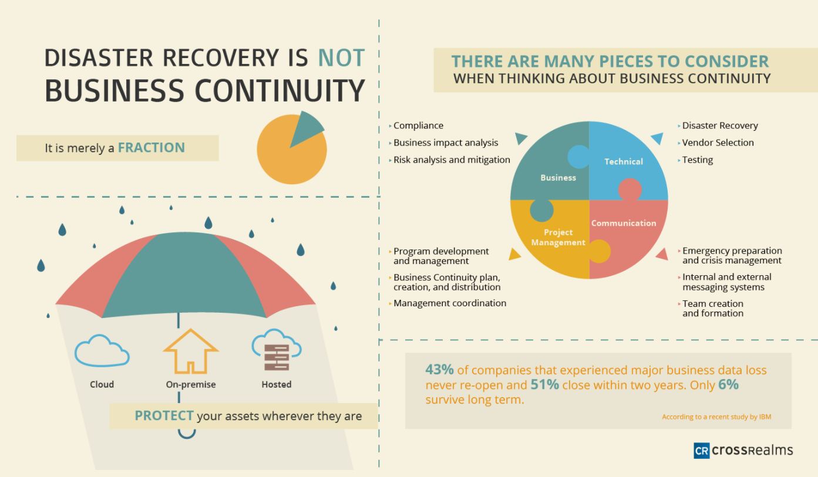

Figure 5 - 12 Disaster Recovery Vs. Business Continuity

*Source: https://www.crossrealms.ca/service-solutions/business-continuity/*

If the office building in New York is impacted by floods, the key employees in the building will be relocated to office buildings in other locations and the other employees will be allowed to work from home or hotel that is away from the disaster location. The customer service operations shall be handled by employees in India and Brazil. The insurance company should be contacted as soon as possible. After the disaster, the utilities at the building must be disconnected and the building must be secured. Examine and document the damage and find if any resources are still useful.

The sales operation will be taken over by teams in Nevada, Minnesota, and Nebraska to ensure the business will continue to make a profit by managing the supply chain. The program managers are responsible for managing coordination and ensuring development and management programs are operating. Team leaders are responsible for creating and grouping employees into respective teams. Internal and external systems should be able to support communication and collaboration. In the case of cyber terrorism, the legal team should handle all media escalations and maintain the corporation’s reputation.

The acceptable downtime for the business is 8 hours annually with 99.9% availability. However, the operations must be up and running after a disaster with a downtime of 1 hour, so the business is available to its users. The ChaulkBoard Corporation implemented effective measures from its business continuity plans to handle disruptions due to Covid-19 by allowing employees to work from home.

The business continuity plan must be tested, reviewed, and updated annually. It takes time to perfect business continuity plans, so it is important to test and amend them as they will help detect any loopholes or justify the plans. The corporation shall invest 10% of its IT budget in the business continuity plan.

It is possible to outsource bits of BCP, but it is perhaps not realistic to consider assigning overall responsibility to an outside company. BCP can only work when a corporation's inner workforce is directly engaged. Knowing what to keep in-house and what to outsource is crucial to forming a comprehensive and efficient program. (Milligan, 2006)

According to Lee Milligan, the following areas can be outsourced:

* *Risk and Business Impact Analysis* – The *ChaulkBoard* Corporation can get insights through various vendors about the threats the corporation is facing and probabilities of facing those threats.
* *Strategies* – The vendor that provided risk and business impact analysis should be consulted for outlining BCP strategies
* *Recovery and Program Operation* ­– Many third-party benefactors provide excellent disaster recovery consulting and are prepared to support the corporation to meet its disaster recovery and BCP recovery needs.

CONCLUSION

The *ChaulkBoard* Corporation will benefit from transitioning to a SaaS-based e-learning platform. Even though SaaS can be one of the wisest business solutions and offers great benefits, it is important to build SaaS that is efficient and offers demonstrated results to clients. This requires planning in three phases: initiation planning, system planning, and implementation planning. The company will be expanding globally in countries that have good cloud adoption rates and cheaper economies. The disaster recovery plan centers on reestablishing IT systems and operations following a disaster and the business continuity plan centers on reinstating the whole business.

REFERENCES

1. Admin, Web. “How To Design and Develop Successful SaaS Application.” *DevCom*, 2 Nov. 2020, devcom.com/tech-blog/how-to-design-and-develop-saas-application.
2. Eby, Kate. “Demystifying the 5 Phases of Project Management.” *Smartsheet*, 29 May 2018, www.smartsheet.com/blog/demystifying-5-phases-project-management.
3. “IT Management.” *Bu.Edu*, onlinecampus.bu.edu/bbcswebdav/pid-9311635-dt-content-rid-57724872_1/courses/21fallmetcs782_o1/course/module5/allpages.htm. Accessed 10 Oct. 2021.
4. Herrick, Jonathan. “8 Best Practices for Rolling out a New Tool or Process.” *BenchmarkONE*, 9 Aug. 2019, www.benchmarkone.com/blog/8-best-practices-for-rolling-out-a-new-tool-or-process.
5. “About Netflix - Completing the Netflix Cloud Migration.” Netflix, 11 Feb. 2016, about.netflix.com/en/news/completing-the-netflix-cloud-migration.
6. Jayachandran, Janaki. “Janaki Jayachandran.” *Https://Blog.Techcello.Com/*, 6 Apr. 2016, blog.techcello.com/top-10-critical-nfr-for-saas-applications-part-1.
7. Markets, Research And. “Global Software as a Service (SaaS) Market Report 2020: Market Was Valued at $134.44 Bn in 2018 and Is Expected to Grow to $220.21 Bn at a CAGR of 13.1% through 2022.” *Prnewswire.Com*, 6 Dec. 2019, www.prnewswire.com/news-releases/global-software-as-a-service-saas-market-report-2020-market-was-valued-at-134-44-bn-in-2018-and-is-expected-to-grow-to-220-21-bn-at-a-cagr-of-13-1-through-2022--300970629.html.
8. Oliver, Blake. “Determine the ROI of Cloud Accounting with Our Free Calculator.” *FloQast*, 5 Jan. 2019, floqast.com/blog/accounting-software-roi-analysis-calculator.
9. “SaaS Implementation.” *SketchBubble*, www.sketchbubble.com/en/presentation-saas-implementation.html. Accessed 10 Oct. 2021.
10. “SaaS Software Vs. Traditional Software.” *Atlantic.Net*, www.atlantic.net/wp-content/themes/anet/img/what-is/saas/what-is-saas-15.jpg. Accessed 7 Oct. 2021.
11. Kumar, V. S. (2006). Effective requirements management. Paper presented at PMI® Global Congress 2006—EMEA, Madrid, Spain. Newtown Square, PA: Project Management Institute.
12. Carpenter, Steven. “TechCrunch Is Now a Part of Verizon Media.” TechCrunch, 23 Dec. 2015, techcrunch.com/2015/12/23/a-startups-guide-to-international-expansion.
13. Theodosiou, Peter. “Census 2016: Second-Language Learning in Australia ‘Needs Urgent Attention.’” *SBS News*, 28 June 2017, www.sbs.com.au/news/census-2016-second-language-learning-in-australia-needs-urgent-attention.
14. Goasduff, Laurence. “Cloud Adoption Where Does Your Country Rank.” *Gartner*, 19 Aug. 2019, www.gartner.com/smarterwithgartner/cloud-adoption-where-does-your-country-rank.
15. “The Differences Between Outsourcing and Offshoring.” *NIX United – Custom Software Development Company in US*, 27 May 2021, nix-united.com/blog/the-differences-between-outsourcing-and-offshoring.
16. “Help And Training Community.” *Salesforce*, 8 June 2021, help.salesforce.com/s/articleView?language=en_US&type=1&id=000355136.
17. Pierre-Louis, Kendra. “Want to Escape Global Warming? These Cities Promise Cool Relief.” *The New York Times*, 16 Apr. 2019, www.nytimes.com/2019/04/15/climate/climate-migration-duluth.html.
18. DePietro, Andrew. “Here’s How Much Money Software Developers Earn In Every State.” *Forbes*, 29 June 2021, www.forbes.com/sites/andrewdepietro/2019/05/21/software-developer-salary-state/?sh=79d0140f2f2c.
19. “Disaster Recovery Options in the Cloud - Disaster Recovery of Workloads on AWS: Recovery in the Cloud.” *Amazon*, docs.aws.amazon.com/whitepapers/latest/disaster-recovery-workloads-on-aws/disaster-recovery-options-in-the-cloud.html. Accessed 11 Oct. 2021.
20. “Disaster Recovery Plan Template.” *Evolve IP*, 30 Aug. 2021, www.evolveip.net/resources-library/disaster-recovery-plan-template.
21. VeritisAdmin. “How to Plan an Effective Cloud Disaster Recovery Strategy?” *Veritis*, 25 June 2020, www.veritis.com/blog/how-to-plan-an-effective-cloud-disaster-recovery-strategy.
22. “Downtime Cost Calculator.” *Eaton*, powerquality.eaton.com/Products-services/Help-Me-Choose/DowntimeCostCalculator/Default.asp. Accessed 11 Oct. 2021.
23. CrossRealms Inc. “Protect Your Company with Business Continuity Management Services.” *CrossRealms*, www.crossrealms.ca/service-solutions/business-continuity. Accessed 11 Oct. 2021.
24. Milligan, Lee. “Outsourcing BCP: What’s Possible, What’s Not.” *Risk and Resilience Hub*, 7 Sept. 2020, www.riskandresiliencehub.com/outsourcing-bcp-whats-possible-whats-not.
25. Freepik. “Abstract Geometric Green Background Free Vector.” *Freepik*, 28 Nov. 2019, www.freepik.com/free-vector/abstract-geometric-green-background_6189912.htm.